

CSF302
Software Engineering Department

Assignment 1

<Submitted by> Student No:02240337

Royal University of Bhutan, College of Science and Technology

QUESTIONS 1

Answer the following [1m]

a. Write the formal definition of f(n) = Θ(g(n)). Your answer must name every constant used and state the range of n over which the inequalities hold. (0.5)

b. In the Word RAM model of computation, name the two quantities used to measure the cost of an algorithm. (0.5)

2. Consider the following function. Assume n is a power of 2 and n ≥ 2. Use the counting convention stated in the Counting Convention section above.[3m]

{

int sum = 0, i, j;

for (i = 1; i <= n; i = i * 2)

for (j = 0; j < n; j++)

sum = sum + A[j];

return sum;

}

a. State, with justification, how many times the body of the outer loop executes, as a function of n.(0.5)

b. Build the Cost / Repetitions / Total table for this function in the format used in Session 2. (1)

c. From your table, derive the exact expression for T(n). Simplify it fully. (1)

d. State the tightest asymptotic bound for T(n) in Θ notation, and justify it from your expression in

(c) by identifying the dominant term. (0.5)

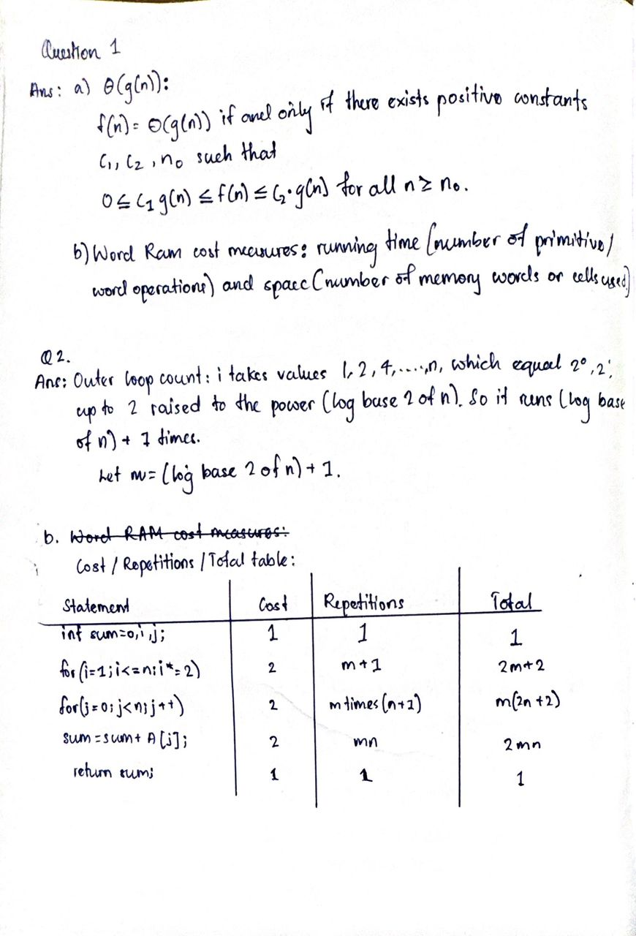

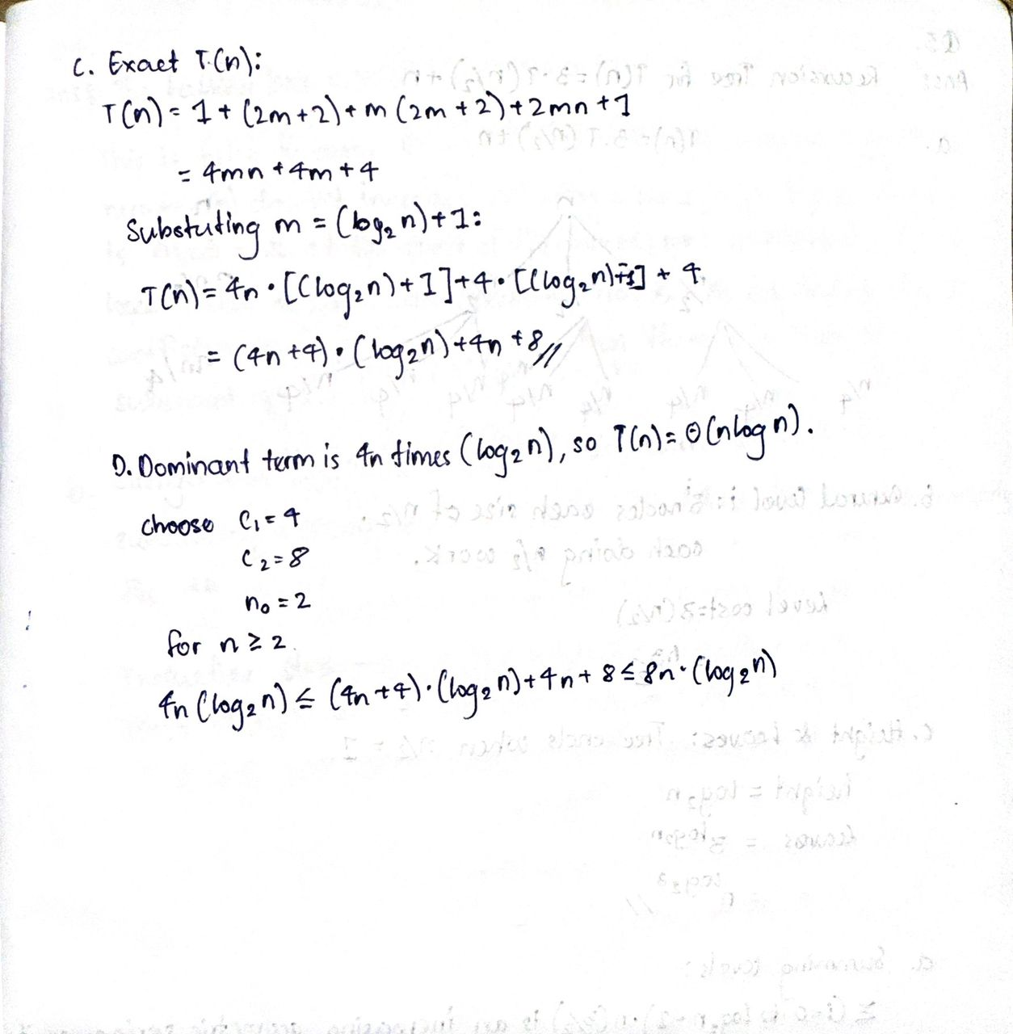

3. Analyze the recurrence T(n) = 3T(n/2) + n, with T(1) = 1, using the recursion tree method. (3m)

a. Draw the top three levels of the recursion tree (levels 0, 1 and 2). Write the local cost inside eachnode and label each level with its total cost. (0.75)

b. (b) For a general level i, state: the number of nodes, the subproblem size, and the total cost of thatlevel. Show how the level cost is obtained. (0.75)

c. (c) Give the height of the tree and the number of leaves, showing how you obtained each. (0.5)

d. (d) Sum the level costs. Identify the type of series you obtain, evaluate it, and state the resultingbound in Θ notation. (0.75)

e. (e) In one or two sentences, state which part of the tree the root, all levels equally, or the leavesdominates the total cost here. Contrast this with T(n) = 2T(n/2) + n and T(n) = 2T(n/2) + n2, both studied in class. (0.25)

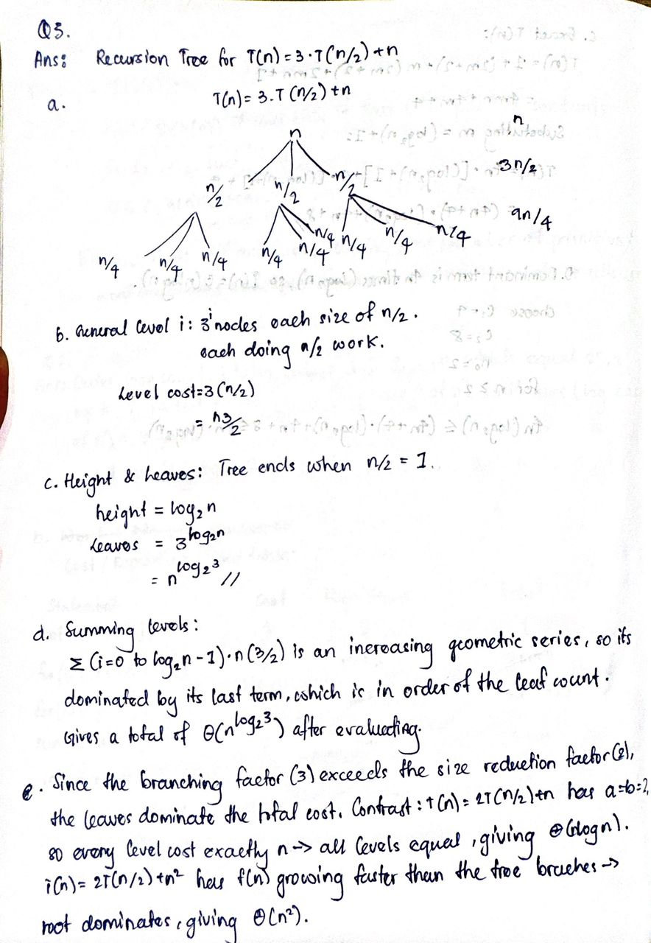

4. A student submits the following proof for T(n) = 4T(n/2) + n, with T(1) = 1: (3m)

Guess. T(n) ≤ cn2

.

Inductive hypothesis. T(k) ≤ ck2 for all k < n.

Inductive step. T(n) = 4T(n/2) + n ≤ 4 · c(n/2)2 + n = cn2 + n ≤ cn2

,

since +n is a lower-order term and is absorbed into the constant.

Therefore T(n) = O(n2

).

a. The stated bound O(n2) is in fact correct, but the proof is not valid.

b. (a) Identify the exact line at which the argument fails and explain precisely why that line does not follow. (1)

c. (b) Repair the proof by strengthening the hypothesis. State the strengthened claim in full. (0.5)

d. (c) Carry out the inductive step for your strengthened claim in full, showing every algebraic line and the condition your new constant must satisfy. (1)

e. (d) Verify the base case, and state explicit values of every constant and of n0 for which your proof holds. (0.5)

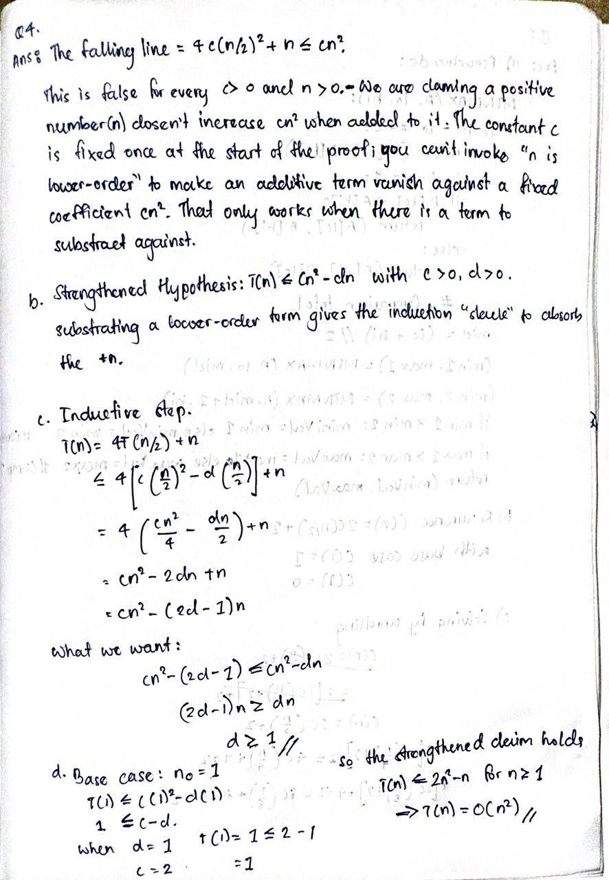

5. The obvious way to find both the minimum and the maximum of an array of n elements is two separate scans, costing 2n − 2 element comparisons. Design a divide-and-conquer algorithm MINMAX (A, lo, hi) that returns both values using strictly fewer comparisons, then verify your analysis experimentally.

a. Write the pseudocode for MINMAX. Handle the base cases for one and two elements explicitly and use no more than two comparisons to combine the results of the two recursive calls. (1)

b. Let C(n) be the number of element comparisons performed on an array of n elements. Derive the recurrence for C(n) and state both base cases. (1)

c. Solve your recurrence using the iterative (unrolling) method. Show at least three expansions, give the general form after k expansions, substitute the value of k at which the base case is reached, and obtain a closed form. State the Θ bound. (1)

d. Implement MINMAX with a comparison counter. Run it on randomly generated arrays for n = 8, 64, 512 and 4096, and present your results in this table

e. State whether measurement matches prediction. In one or two sentences, explain why the agreement here is exact rather than approximate. (1)

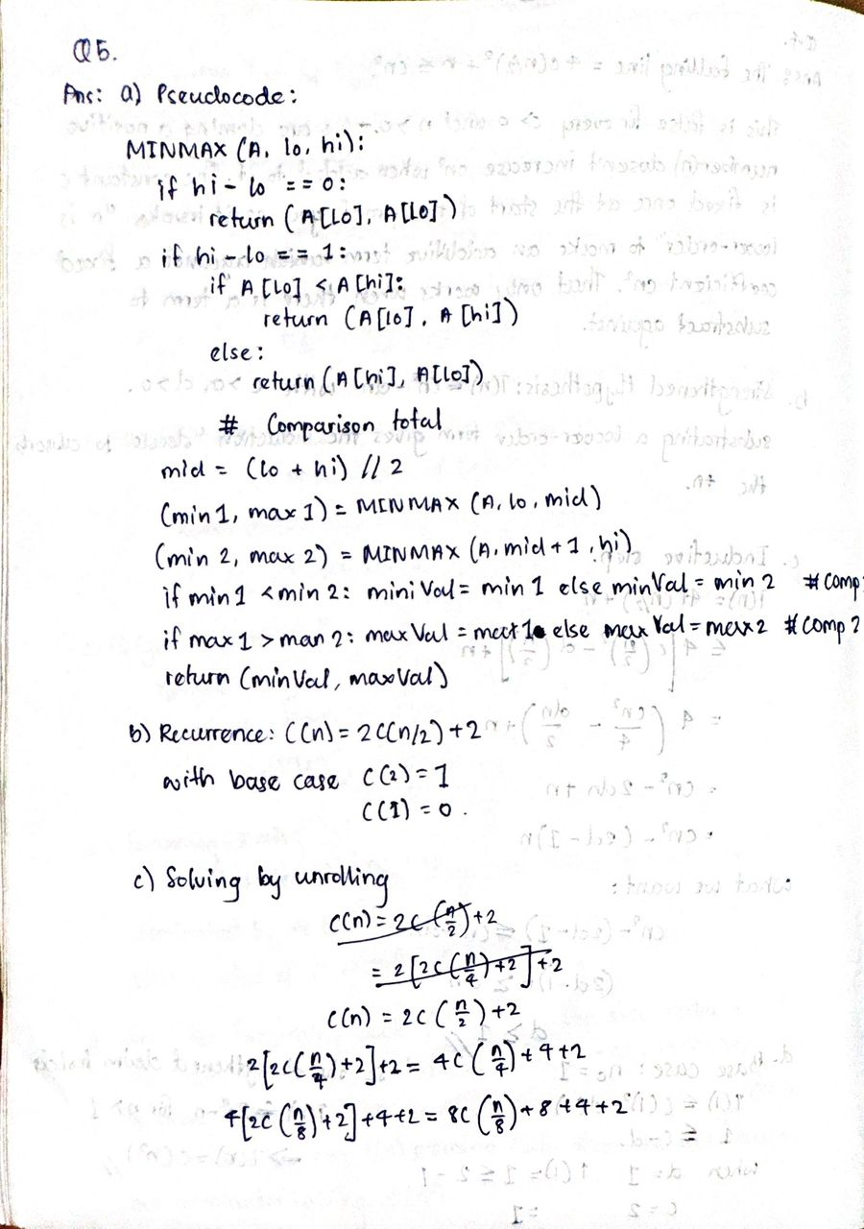

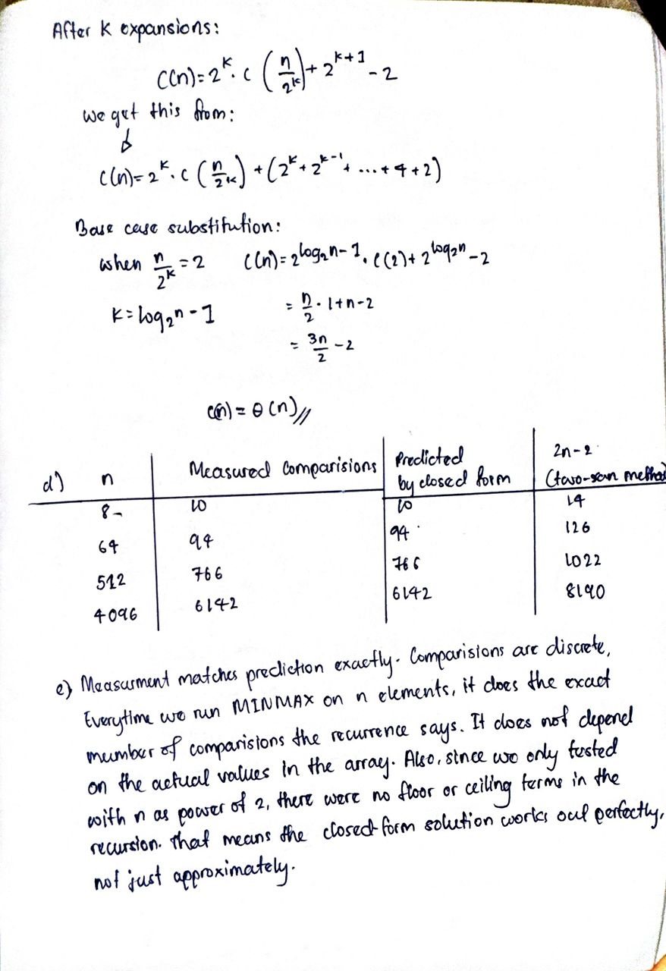

Code:

